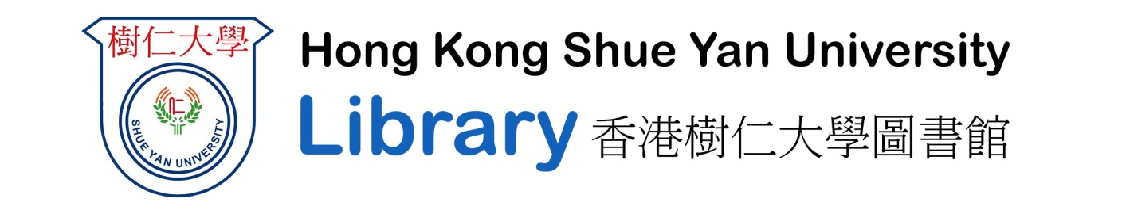
Interlibrary Loan Service Request Form
ILL Ref. code: _______________
Name: _______________________________ Department: _________________________________
Phone: _______________________________ Email: ______________________________________
Interlibrary Loan is a primary service that supports research and teaching activities by providing referral service or obtaining literature not available in our Library from other sources. It is the policy of Hong Kong Shue Yan University Library (hereafter referred to as “the Library”) to acquire all materials stated in course outlines. However, if you find the materials not acquired by the Library and you need them for teaching and research, you may place a request for the material through Interlibrary Loan. Please fill in the bibliographic information of material in the following space. The Library will verify that the material is not in the library collection. Then, the Library will try to obtain the material by interlibrary loan service from local or overseas university libraries. The Library cannot guarantee the fulfillment of the request as other university libraries may refuse our requests on any grounds they think appropriate. Before you decide to request the ILL service, please make sure you have read our ILL service policy at the library webpage www.hksyu.edu.hk/lib

Request For: Teaching preparation / Research / Other (please specify) ______________________________
What service level would you like: Regular / Rush Need before date: _____________________
Details of the item
Format: Book / Journal Article
Book/Article Title: ______________________________________________________________________
Journal Title: _________________________________________ Issue/Volume: ______________________
Author: _____________________________________________ Edition (Book): _____________________
Publisher: _____________________________ ISBN/ISSN: ______________________________________
Other information: _______________________________________________________________________
Name of Institutions own the item: __________________________________________________________

WARNING C O P Y R I G H T R E S T R I C T I O N S
The Hong Kong Copyright Ordinance (Cap. 528) governs the making of photocopies or other reproductions of copyrighted materials.
Under certain conditions specified in the ordinance, libraries and archives are authorized to furnish a copy or other reproduction. One of these specified conditions is that the photocopy or reproduction is not to be “used for any purpose other than private study and research.” If a user makes a request for, or later uses, a photocopy or reproduction for purposes in excess of “fair dealing,” that user may be liable for copyright infringement.
Hong Kong Shue Yan University Library reserves the right to refuse to accept a copying order, if in its judgement, fulfillment of the order would involve violation of copyright law.
Please sign below to indicate you have read and understand this statement!

Signature: _________________________________ Date: ________________________________

